Email to soon-to-expire policyholders

Dear (Policyholder First Name),
Although your flood insurance policy is about to expire, we’ve just launched our new version of (insert your company’s ManageFlood link if it’s emailed – otherwise type in the web address after “ManageFlood”), where you will be able to make your renewal payment online without even having to login!
To pay your flood insurance premium:
- Retrieve your renewal bill.
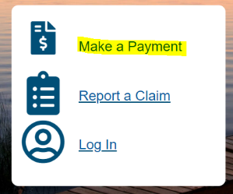
- If you don’t have it, let me know and I’ll send it to you.

- Go to (insert your ManageFlood web address).
- Select “Make a Payment” and on the next page, select “Renewal Bill”.
- Follow the directions to find your policy number and bill ID (they will be on your renewal bill).
- Follow the prompts to securely pay for your flood insurance policy.
Here’s also a brief video on how to pay your flood insurance renewal bill online.
If you have any questions about your flood insurance policy, please reach out. I’m here for you and am happy to help with your financial and peace-of-mind protections.
Best regards,
(Email or Print Signature)

